Walk 4 The Spectre of Glyndwr
Last walked in March 2019

Description. A 7 km (4.3 mile) hilly walk across field paths, lanes, woods and common.
Start. Near Westhope Bus Shelter. Explorer Map 202 Grid 464510.
Directions from Whitecross roundabout (Turn milometer to zero). Take the A4110 Canon Pyon (Three Elms road). At 6.4 miles, after just passing thru Canon Pyon, you TR onto a minor road to Westhope. At 7 miles at a T-junction you TL, the road bends to the R then goes thru Westhope and just before a red post box and a bus shelter [7.3m] you turn sharp L. After 200 meters you can park on the R hand side of the road.

The Spectre of Owain Glyndwr. Glyndŵr was born in 1359. On 16 September 1400, Glyndŵr instigated the Welsh Revolt against the rule of Henry IV of England. Although initially successful, the uprising was eventually put down. Glyndŵr was never captured nor tempted by royal pardons and never betrayed. His final years are a mystery. Owain’s wife Margaret along with two of his daughters were taken prisoner and incarcerated in the Tower of London. They were all to die in the Tower before 1415. The Great Welsh Rebel was in fear for his life, not expecting a pardon from the new king, Henry V, and living out an existence in deserted places and caves. Tradition has it that he died and was buried possibly in Corwen church of SS Mael & Sulien close to his home, or possibly at his estate in Sycharth or on the estates of his daughters' husbands — Kentchurch in south Herefordshire or Monnington in west Herefordshire. Glyndŵr has remained a notable figure in the popular culture of both Wales and England, portrayed in Shakespeare's play Henry IV, Part 1 (as Owen Glendower). In 2000, celebrations were held all over Wales to commemorate the 600th anniversary of the Glyndŵr rising.

1. The Hamlet of Westhope. Return back down the road to Westhope and bearing L at the T-junction you pass the bus shelter and red post box on your L. 30 meters further on, opposite a house called ’Speedwell’, you TR, cross the road and go a short way along a drive, then fork R off the drive and along a public footpath and thru a metal gate/stile and into an open field F1. Turn half R, and half way up the field you go thru a small wooden gate into F2. Walk slightly L to cross over another stile/metal gate into F3. About 50m along the R hand edge TR thru a metal gate into F4. TL to walk along the L hand edge of this field and thru a metal gate into F5. Keep to the L hand edge of this field and go thru a gate, down steps, across a sunken path, up steps, across a stile into F6. Keep to the L field edge to cross over a stile into F7. Continue along the R hand edge of this field to go thru a metal rusty gate on your R and into F8. Immediately TL and go thru a newer metal gate into F9. Go to the end of this field, keeping the hedge on your L, to cross a metal gate onto a wide stone and concrete farm drive.

2. Lawton’s Hope Wood. TL, walk up the drive for about 40m and then TL thru a metal gate and walk up a stony pathway to go thru another gate into a wood. Walk along the stony pathway for about 100m, when the pathway starts bending R, you continue straight on, along a not so well defined, unmarked dirt track, (if you reach a T-junction on the stony pathway you have gone to far). 100m further on you go thru a metal gate into F10. On the same line but bearing slightly R, slope down the field, and not far from the bottom you TR thru a metal gate into F11. With the tree line on your L, continue along the L hand edge of this field for about 80m and TL, to cross over a two-plank footbridge into F12. Climb a steep bank, keeping near to the fence/hedge on your L. Ignore the small wooden gate(L) and continue on up the L field edge to reach the top, where you go thru a small wooden gate onto a farm track. TL, after a few paces TR to climb five steps and continue up an enclosed track. You then climb 16 more steps onto cross paths, where you TR and continue up an enclosed public footpath, (Holly Hall Cottage is on your R and Stone Cottage is on your L side). After about 80m TR at cross tracks and continue up hill along a public footpath to reach Backwoods House gateway on your R, the gateway consists of two metal gates with stone statues of lions on each post.

3. Lion Statue. Continue in the same direction up an enclosed track to go thru a small wooden gate into F13. TL, follow the edge of the field that bends R and a little further on it turns sharp L (by a way mark sign). At this point don’t TL but go straight on up across the field, passing a concrete water trough, to cross a stile onto a well defined stony track. TL and go along the track, after passing ‘Rose Cottage’ on your R the track gets wider. Continue along this wide stony track to a triangle and onto a tarmaced road.
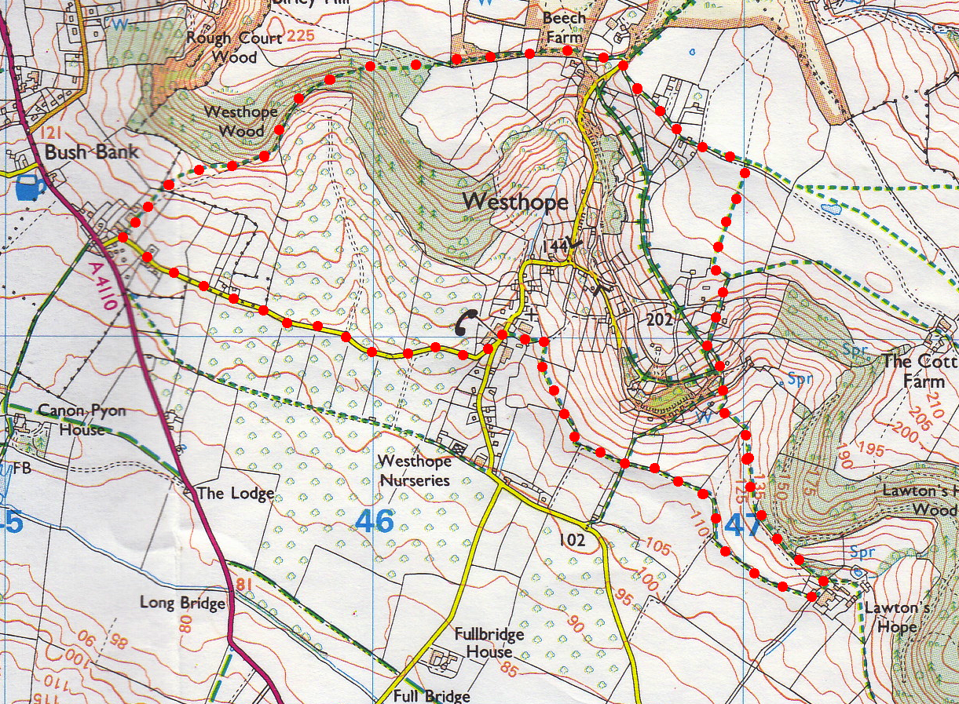
4
4. Beech Farm. TR, go along the road for a few paces and just before a cattle grid you TL and go along an enclosed public footpath, then between buildings and onto the end of a tarmac road. TR then after a few paces you TL and go thru a small wooden gate that is next to a metal gate. Keep to the L hand fence/hedge and continue on in the same direct until you reach a metal gate. Go thru the gate and continue along an enclosed track to reach a small wooden gate on your L. TL thru the gate and into into Westhope Wood. Go downhill for about 130 meters to a track T-junction by a marker post and TL. Continue down for about 35 meters and TR at another marker post. Bear L at the next marker post, and continue along the inside edge of the wood to go thru a small wooden gate, out of the wood and into an open field.
3
1
5

5. Westhope Wood. TR and continue along the field edge keeping the fence/wood on your R. When you get to the field corner TL, and with the fence on your R continue down to the next corner but before you reach it bear L and head for the rusty looking gate with a way mark sign and a tall wooded pole attached to one side. Go thru the gate and continue down to the L of farm buildings and on to a road. TL and three quarters of a mile along road you arrive at the start point.
2

